# BIGTREETECH

**ST820 V1.0 使用说明**

## 一、产品简介

1、ST820 是一款步进电机的集成驱动器，带有内置转换器，易于操作。该产品可在全、半、1/4、1/8 、

1/16 、1/32、1/128 及 1/256 步进模式时操作双极步进电动机。该驱动提供了一整套保护，包括过流保护、过温保护和短路保护。ST820 是一个易于使用在 3D 打印机上面的步进电机驱动板。该驱动外部设备少，不需要额外的部件，为步进电机驱动器提供了更简洁的解决方案。

Introduction:

ST820 is an integrated driver for stepper motors with a built-in converter for easy operation.The product can operate bipolar stepping motors in full, half, 1/4, 1/8, 1/16, 1/32, 1/128 and 1/256 stepping modes.

The drive provides a complete range of protection including overcurrent protection, overtemperature protection and short circuit protection.ST820 is a stepper motor driver board that is easy to use on a 3D printer.The drive has fewer external devices and requires no additional components, providing a simpler solution for stepper motor drives.

## 二、产品参数

1、电机电源电压：7V---45V

2、逻 辑 电 压 ：3V---5.5V

3、最大输出电流：0A---1.5A

4、最 大 细 分 ：1/256 细分

5、驱 动 电 流 ：可调

Parameter

1.Motor power supply voltage: 7V---45V

2.logic voltage: 3V---5.5V

3.the maximum output current: 0A---1.5A

4.the largest sub-division: 1/256 subdivision

5. drive current: adjustable

## 驱动板位图与引脚功能

Driver board bitmap and pin function

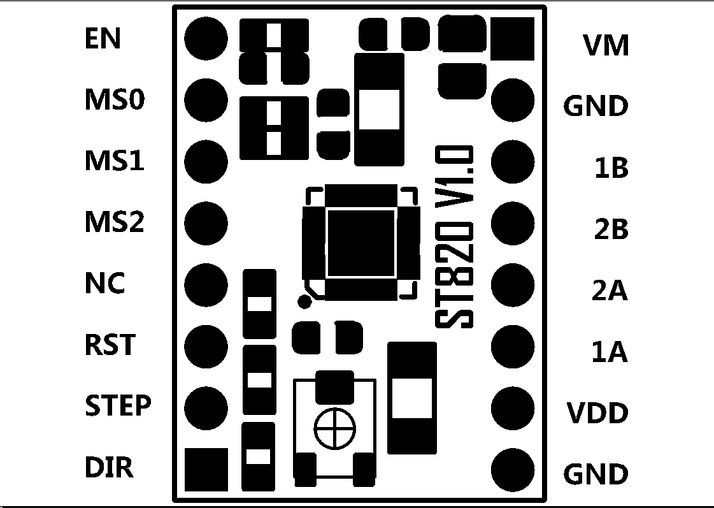

|  |  |  |  |
| --- | --- | --- | --- |
| J1 | Function | J2 | Function |
| 1 | （EN）Enable | 1 | （VM）Motor supply voltage |
| 2 | （MS0）Subdivision selection input | 2 | GND |
| 3 | （MS1）Subdivision selection input | 3 | 1B |
| 4 | （MS2）Subdivision selection input | 4 | 2B |
| 5 | NC | 5 | 2A |
| 6 | （RST）Working Mode | 6 | 1A |
| 7 | （STEP）Pulse input | 7 | （VDD）Logic voltage input |
| 8 | （DIR）Direction input | 8 | GND |

**四、细分选择设置**

输入 MS0、MS1、MS2 来设置驱动的细分值，如下：

Enter MS0, MS1, MS2 to set the drive's subdivision value as follows:

|  |  |  |  |
| --- | --- | --- | --- |
| MS2 | MS1 | MS0 | **Subdivision** |
| 0 | 0 | 0 | **Full step** |
| 0 | 0 | 1 | **1/2 step** |
| 0 | 1 | 0 | **1/4 step** |
| 0 | 1 | 1 | **1/8 step** |
| 1 | 0 | 0 | **1/16 step** |
| 1 | 0 | 1 | **1/32 step** |
| 1 | 1 | 0 | **1/128 step** |
| 1 | 1 | 1 | **1/256 step** |

## 五、驱动电流

1、电位器用来调节 ST820 PWM 电流控制器的参考电压，设置电机相位的峰值电流输入。顺时针旋转增加电流，逆时针旋转减小电流。范围取决于 VDD 逻辑电源电压（J2 的引脚 7），如下表所示：

2、由于是 PWM 控制电流，所以可以出现最小电流。

3、ST820 的过流保护可以限制实际的峰值电流。

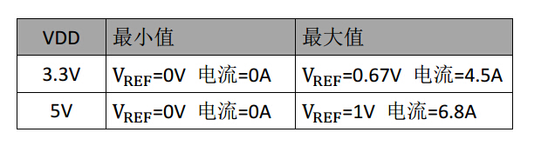

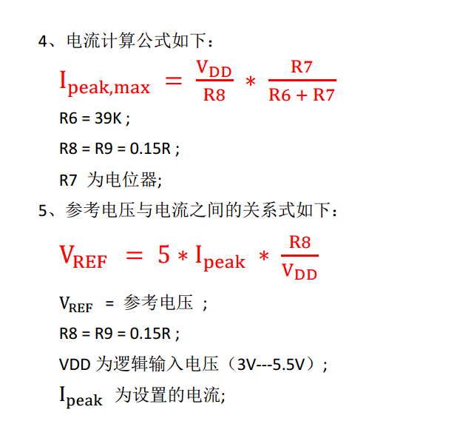

Drive current

1. Potentiometer is used to adjust the parameters of ST820 PWM current controller

Test the voltage and set the peak current input of motor phase. Clockwise rotation

Increase current, decrease current by counterclockwise rotation. The scope depends on VDD

Logical power supply voltage (pin 7 of J2), as shown in the following table:

2. Because PWM controls the current, the minimum current can appear.

3. The overcurrent protection of ST820 can limit the actual peak current.

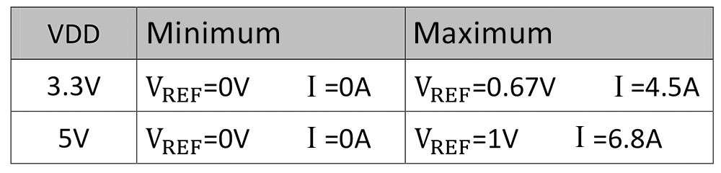

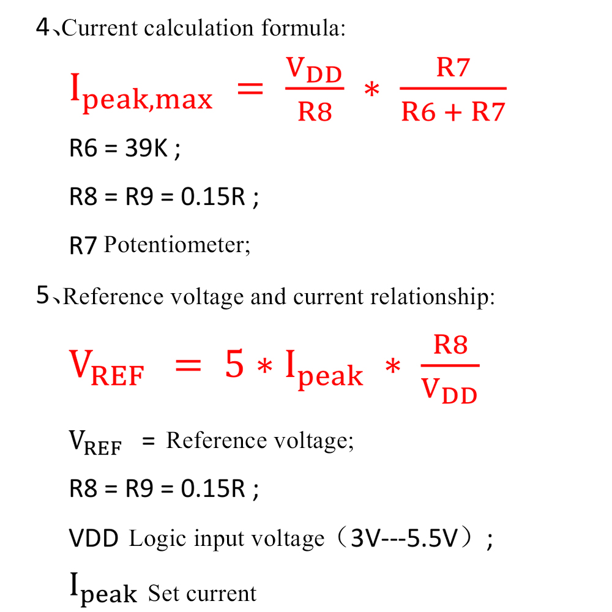

## 六、固件修改方法

由于该驱动与 8729、A4988 等驱动的使能（ENABLE） 信号相反，所以使用该驱动替换以上等驱动时需要自行修改固件。

①打开固件，找到“Configuration.h”文件。

Firmware modification method

Since the driver with 8729, A4988 and other drivers ENABLE (ENABLE)

Signals are reversed, so it is necessary to replace the above drivers with this driver

Line to modify firmware.

①Open the firmware and find the “Configuration.h”file.

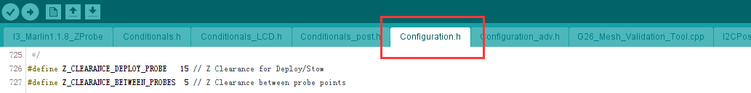

②在该项目文件中找到

②Found in the project file

“#define X_ENABLE_ON 1”

“#define Y_ENABLE_ON 1”

“#define Z_ENABLE_ON 1”

“#define E_ENABLE_ON 1”

将后面的值修改为“1”即可。

Change the following value to "1".

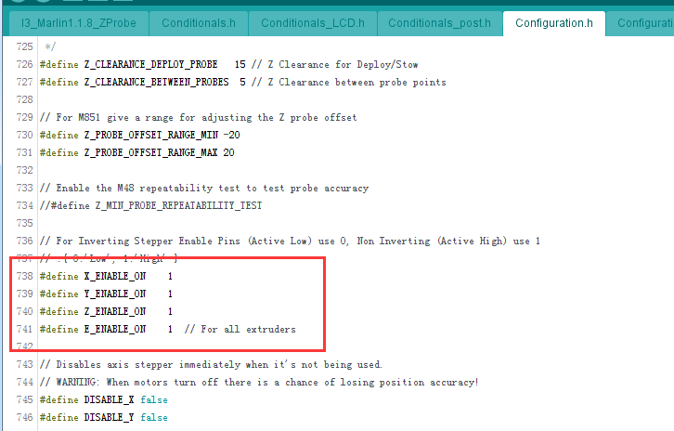

③ 使用时如果方向相反， 则需要修改方向。在

When you use it, if it's the opposite, you need to change direction. in"Configuration. h" file

“Configuration.h”文件中找到

“#define INVERT_X_DIR true” “#define INVERT_Y_DIR false” “#define INVERT_Z_DIR false”等...

将对应相反的轴后面“true”改为“false”或“false” 改为“true”即可调整方向。

Change "true" to "false" or "false" to "true" after the opposite axis to adjust the direction

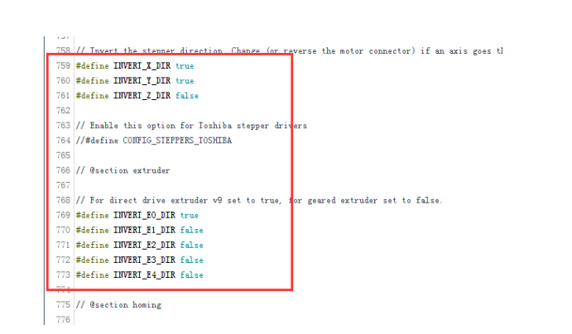

注意事项：

1、该驱动的使能（ENABLE）控制信号与 4988、8729

等驱动的信号是相反的，使用该驱动替换以上等驱动

时，需要修改固件的使能（ENABLE）信号，方向相反

时还需要修改方向。

2、由于驱动工作时发热较大，所以在室内温度较高

的情况下，请尽量选择低一点的细分或者给驱动加散

热风扇，防止温度过高烧毁驱动。

3、在调节电位器设置电流时，请拔掉电机，以免烧

毁驱动。

4、不要在带电的情况下插拔电机，以免损坏驱动。

5、安装散热片时，请注意散热片与排针引脚之间不

能接触，防止驱动短路。

Notes:

1, the driving ENABLE control signal with 4988, 8729

And the driver signal is the opposite, use the driver to replace the above driver

When, need to modify the firmware ENABLE signal, in the opposite direction

You also need to change the direction.

2. The indoor temperature is relatively high due to the large heat generated during the driving operation

In the case of, please try to choose a lower subdivision or add to the driver

Hot fan prevents excessive temperature from burning the drive.

3. When adjusting the potentiometer setting current, please unplug the motor to avoid burning

Drive.

4. Do not plug and unplug the motor when it is live, so as not to damage the drive.

5. When installing heat sink, please pay attention to the gap between heat sink and pin pin

Can contact, prevent drive short circuit.